1. Conduct a one tailed test of significance (hypothesis test with α = 0.01) to test the claim that the intrinsic group has a higher mean creativity score than the extrinsic group. Be sure and show all 6 steps. Use SAS (Elliot and Woodward page 189 and the sample code in the SAS folder on Blackboard) to produce your statistics and conduct your test but don’t simply turn in computer output. Write it in the form of the six steps we covered in class and pay close attention to step 6: Writing the conclusion of the test in non-statistical / easy to understand terms. Do you need to divide the p-value in half? Why or why not?
$H_{0}:μ_{i}>μ_{e}$

$H_{a}:μ_{i}=μ_{e}$

2. t –stat = -2.92
3. p-Value = 0.9972
4. Accept the null hypothesis.
5. With a $p$-value of 0.9972, we accept the null hypothesis that that the intrinsic group has a higher mean creativity score than the extrinsic group.
6. Construct the appropriate confidence interval (correct confidence level) for the test in question 1 and report the plausible values of the difference in mean creativity score between the intrinsic and extrinsic groups. Is it consistent with the test conducted in question 1?

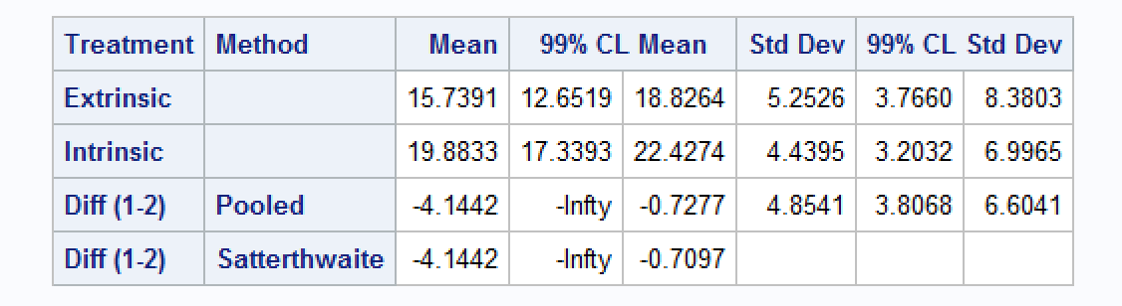

1. What assumptions were made in question 1 so that we could use the two sample t test? Use histograms and possibly other statistical tools to check these assumptions.
   1. We would need to assume that the two means would be equal.
   2. By using a two sided t-test
      1. t –stat = -2.92
      2. p-Value = 0.0056
      3. A negative sign implies that the sample mean is less than the hypothesized mean